1. **Introduction**

I am developing a legal language model (LLM) product tailored for comprehensive tax planning. This product will offer the following capabilities:

1. Assist users in navigating tax compliance to ensure adherence to legal standards.
2. Provide expert solutions to a wide array of tax-related queries.
3. Optimize tax strategies to minimize tax liabilities effectively.
4. **Construct a Console with ChatGPT APIs**

Firstly, I develop a console using ChatGPT API to generate the results. Here are the details:  
*You: Hello*

*Assistant: Hello! How can I assist you today?*

*You: I am developing a legal language model (LLM) product tailored for comprehensive tax planning. This product will offer the following capabilities:*

*1. Assist users in navigating tax compliance to ensure adherence to legal standards.*

*2. Provide expert solutions to a wide array of tax-related queries.*

*3. Optimize tax strategies to minimize tax liabilities effectively.*

*Could you please generate a workingflow of my product?*

*Assistant: Certainly! Here is a suggested workflow for your legal language model (LLM) product tailored for comprehensive tax planning:*

*1. User Input:*

*- Users input their specific tax-related queries or scenarios into the LLM product.*

*2. Natural Language Processing (NLP):*

*- The product utilizes NLP technology to analyze and understand the user's input, extracting key information and identifying the relevant legal standards and regulations.*

*3. Compliance Check:*

*- The LLM product cross-references the user's input with current tax laws and regulations to ensure compliance and adherence to legal standards.*

*4. Expert Solutions:*

*- Based on the analysis of the user's input and legal standards, the product provides expert solutions and recommendations for addressing the tax-related queries effectively.*

*5. Tax Strategy Optimization:*

*- The LLM product offers personalized tax strategies tailored to the user's specific circumstances, aiming to minimize tax liabilities and maximize tax savings.*

*6. Interactive Feedback:*

*- Users can interact with the product to ask follow-up questions, seek clarification on recommendations, and receive further guidance on tax planning strategies.*

*7. Continuous Learning:*

*- The LLM product continuously learns from user interactions and feedback, improving its accuracy and effectiveness over time.*

*8. Reporting and Documentation:*

*- The product generates reports summarizing the tax strategies recommended, compliance checks performed, and any other relevant information for users to reference and document their tax planning efforts.*

*9. Customer Support:*

*- Users can access customer support for additional assistance, troubleshooting, and guidance on using the LLM product for their tax planning needs.*

*I hope this workflow provides a helpful framework for developing your tax planning LLM product! Let me know if you need further assistance or have any other questions.*

*You: Our target users encompass a broad spectrum, including entrepreneurs, law and accounting firms, individual taxpayers, and government agencies. This diverse user base will benefit from our product’s robust functionality designed to meet their specific tax planning needs.*

*please help me to generate each user story.*

*Assistant: Certainly! Here are user stories for each target user group of your legal language model (LLM) product tailored for comprehensive tax planning:*

*1. Entrepreneur:*

*As an entrepreneur, I want to use the LLM product to ensure that my business is compliant with all tax laws and regulations, so that I can focus on growing my company without the worry of potential tax liabilities.*

*2. Law and Accounting Firm:*

*As a law and accounting firm, I need the LLM product to provide expert solutions to complex tax-related queries for our clients, allowing us to offer comprehensive tax planning services and optimize tax strategies effectively.*

*3. Individual Taxpayer:*

*As an individual taxpayer, I want to utilize the LLM product to navigate tax compliance and receive personalized tax strategies to minimize my tax liabilities, ensuring that I am making informed decisions about my finances.*

*4. Government Agency:*

*As a government agency, we require the LLM product to assist in analyzing and interpreting tax laws and regulations, enabling us to enforce compliance effectively and provide accurate guidance to taxpayers.*

*Each user story reflects the unique needs and goals of the target user groups, showcasing how your LLM product can provide value and support their specific tax planning requirements. I hope these user stories help guide the development and implementation of your product for a diverse user base. Let me know if you need additional assistance or have any other questions.*

*You: Could you please visualize the previous workflow?*

*Assistant: Here is the image for 'The image description is "visualize the previous workflow."':*

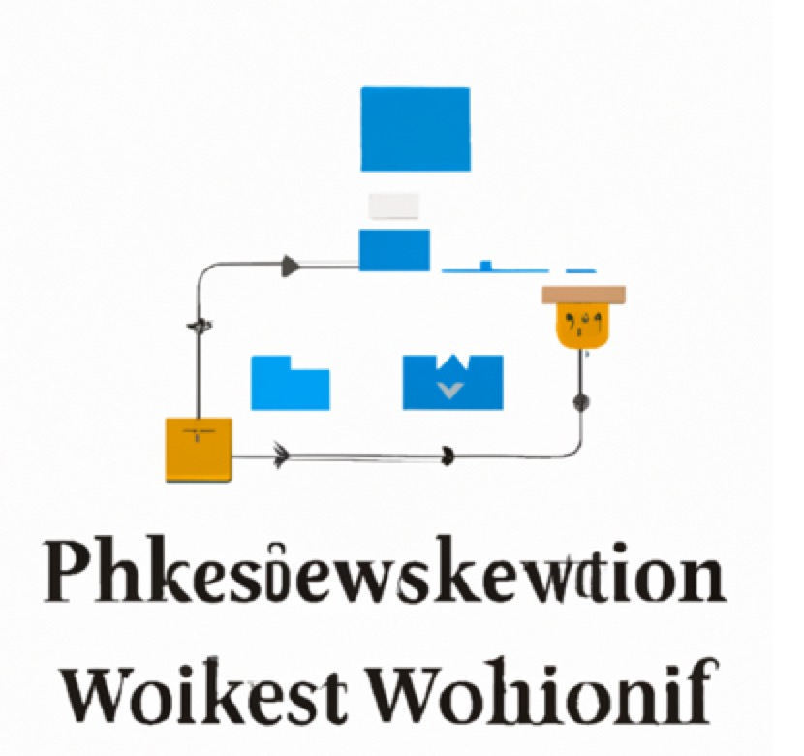

*You: Maybe you can use markdown instead of generate the figure,*

*Assistant: Sure! Here is the previous workflow presented in a markdown format:*

*```*

*1. User Input:*

*- Users input their specific tax-related queries or scenarios into the LLM product.*

*2. Natural Language Processing (NLP):*

*- The product utilizes NLP technology to analyze and understand the user's input, extracting key information and identifying the relevant legal standards and regulations.*

*3. Compliance Check:*

*- The LLM product cross-references the user's input with current tax laws and regulations to ensure compliance and adherence to legal standards.*

*4. Expert Solutions:*

*- Based on the analysis of the user's input and legal standards, the product provides expert solutions and recommendations for addressing the tax-related queries effectively.*

*5. Tax Strategy Optimization:*

*- The LLM product offers personalized tax strategies tailored to the user's specific circumstances, aiming to minimize tax liabilities and maximize tax savings.*

*6. Interactive Feedback:*

*- Users can interact with the product to ask follow-up questions, seek clarification on recommendations, and receive further guidance on tax planning strategies.*

*7. Continuous Learning:*

*- The LLM product continuously learns from user interactions and feedback, improving its accuracy and effectiveness over time.*

*8. Reporting and Documentation:*

*- The product generates reports summarizing the tax strategies recommended, compliance checks performed, and any other relevant information for users to reference and document their tax planning efforts.*

*9. Customer Support:*

*- Users can access customer support for additional assistance, troubleshooting, and guidance on using the LLM product for their tax planning needs.*

*```*

*I hope this markdown format helps visualize the workflow for your legal language model (LLM) product tailored for tax planning. Let me know if you need further assistance or have any other requests.*

*You: I mean the markdown to generate flow*

*Assistant: Certainly! Here is the workflow presented in a markdown format using a flowchart:*

*```mermaid*

*graph TD;*

*UserInput-->NLP;*

*NLP-->ComplianceCheck;*

*ComplianceCheck-->ExpertSolutions;*

*ExpertSolutions-->TaxStrategyOptimization;*

*TaxStrategyOptimization-->InteractiveFeedback;*

*InteractiveFeedback-->ContinuousLearning;*

*ContinuousLearning-->ReportingDocumentation;*

*ReportingDocumentation-->CustomerSupport;*

*```*

*I hope this markdown flowchart visualization helps illustrate the workflow for your legal language model (LLM) product tailored for tax planning. Let me know if you need further assistance or have any other requests.*

From the results, I can see the APIs could give some useful results but the generated figure is not clear regarding the logic and word and even there are some mistakes.

1. **Use OpenAI console**

I use ChatGPT-o1 preview to help me create the working flow:  
**1. User Onboarding and Profile Setup**

* **User Registration:** Securely gather user information and create an account.
* **Profile Customization:** Collect specific tax-related details such as business type, location, financial year, etc.
* **Access Control:** Set permissions for different levels of users (e.g., accountants, business owners).

**2. Tax Compliance Navigation**

* **Regulation Updates:** Automatically update the system with the latest tax laws and compliance requirements using a dynamic database.
* **Compliance Checklist:** Provide a customizable checklist based on the user's profile to ensure all compliance aspects are covered.
* **Alerts and Notifications:** Send timely notifications about upcoming filing deadlines and compliance changes.

**3. Query Handling and Support**

* **Interactive Query System:** Implement a chatbot or query system that users can interact with to ask tax-related questions.
* **Expert System Integration:** Use an AI-driven expert system that provides detailed, context-specific answers to complex queries.
* **Resource Library:** Offer access to a comprehensive library of tax articles, case studies, and FAQs.

**4. Tax Optimization Strategies**

* **Scenario Analysis:** Allow users to input different financial scenarios to see potential tax implications.
* **Strategy Recommendations:** Use AI algorithms to suggest the most effective tax-saving strategies tailored to the user's specific circumstances.
* **Report Generation:** Enable users to generate reports that outline potential tax strategies and their expected impacts.

**5. Continuous Learning and Adaptation**

* **Feedback System:** Incorporate a feedback loop where users can rate and review the advice and information provided, helping the system learn and improve.
* **Machine Learning Integration:** Employ machine learning techniques to refine strategies and solutions based on new data and outcomes.
* **User Education:** Provide ongoing education modules and updates on tax strategies and changes in tax law.

**6. Security and Data Management**

* **Data Encryption:** Ensure all user data is encrypted both in transit and at rest.
* **Regular Audits:** Conduct regular security audits and compliance checks to maintain high security and data integrity standards.
* **Data Backup:** Implement robust data backup protocols to prevent data loss.

**7. User Interface and Experience**

* **Dashboard Design:** Create a user-friendly dashboard that provides a holistic view of the user's tax status, alerts, and suggestions.
* **Customizable Interfaces:** Allow users to customize the layout and types of information displayed.
* **Mobile Compatibility:** Ensure the platform is accessible via mobile devices for on-the-go access.

Limited to the figure generation style, the visualizations are not clear and straightforward:  
prompt: Could you please visualize the previous workflow?

Result:  
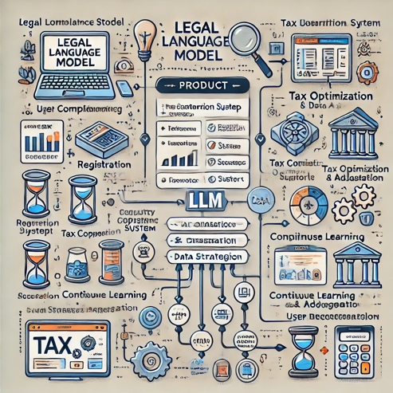

Prompt: I would like a more professional style.

Result:

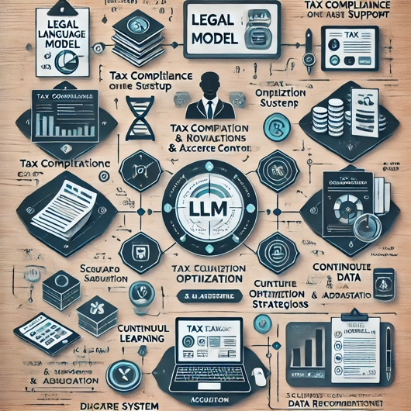

Prompt: The word is not clear. Please generate a plain one.

Result

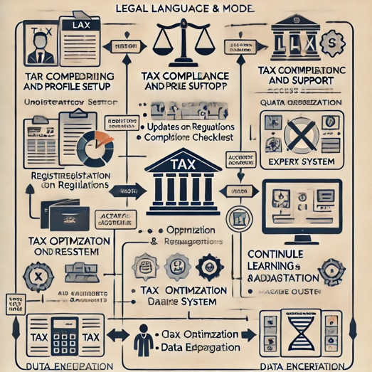

Then I use another application based on ChatGPT API to draw the diagram ([Link](https://chatgpt.com/share/66e5e5c8-496c-800c-8747-8569fa2da2a4)):  
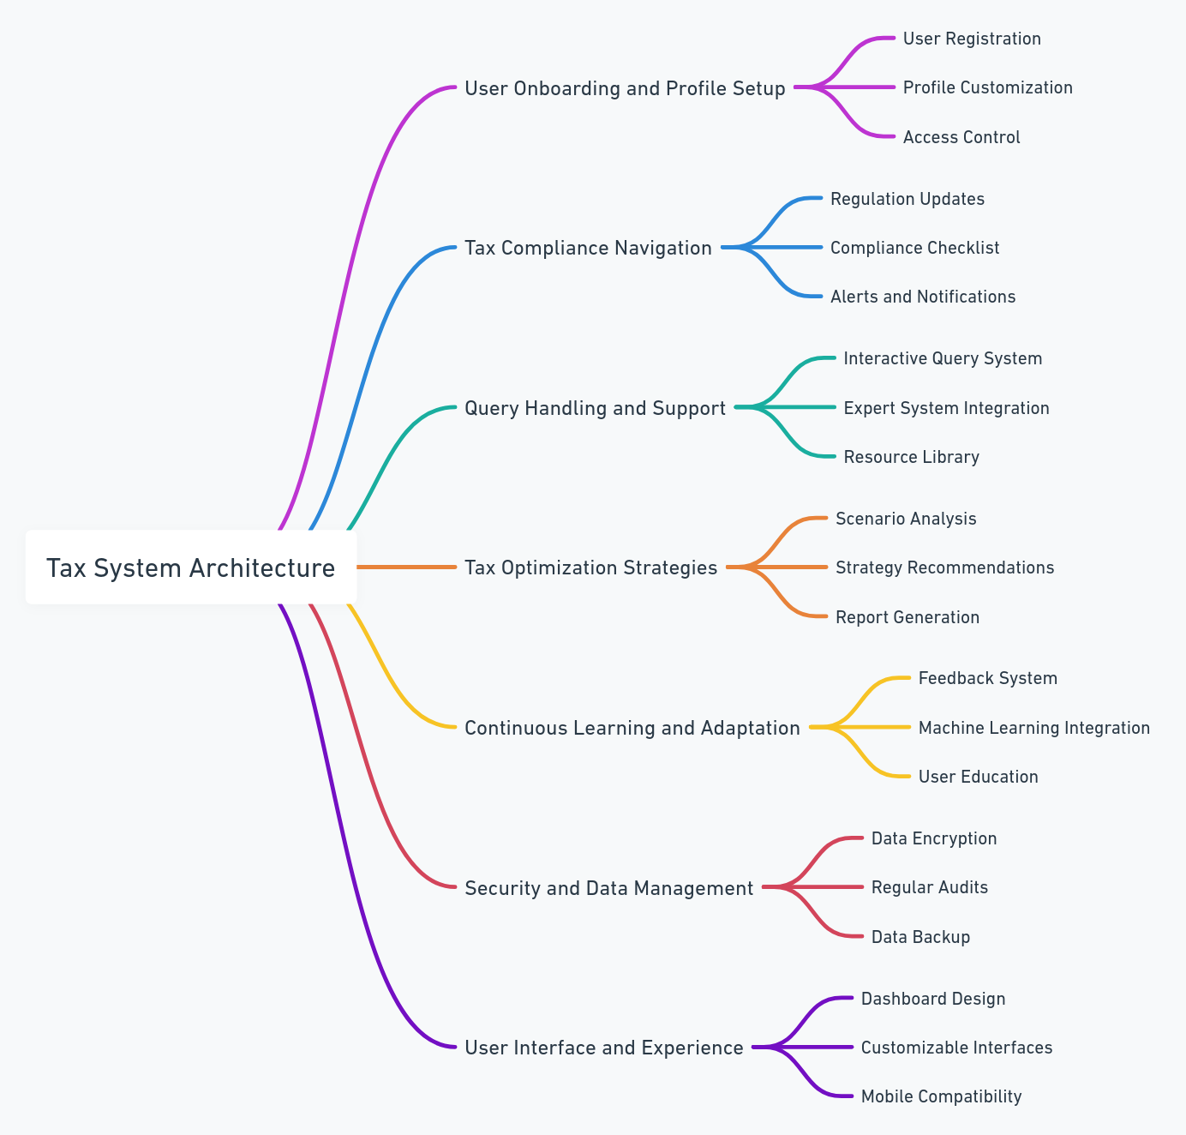

Our target users encompass a broad spectrum, including entrepreneurs, law and accounting firms, individual taxpayers, and government agencies. This diverse user base will benefit from our product’s robust functionality designed to meet their specific tax planning needs.

Here are the ChatGPT’s user stories:  
Creating user stories for each segment of your target audience is crucial to ensure the product meets their specific needs. Here's a breakdown of user stories for entrepreneurs, law and accounting firms, individual taxpayers, and government agencies:

**Entrepreneurs**

**As an entrepreneur, I want to:**

1. **Easily understand my tax liabilities** so that I can plan my finances without needing specialized knowledge.
2. **Receive alerts for relevant tax deductions and credits** to reduce my taxable income legally.
3. **Generate tax planning scenarios** based on future income projections to better understand potential financial outcomes.
4. **Access industry-specific tax compliance guidelines** to ensure my business adheres to relevant laws.

**Law and Accounting Firms**

**As a law/accounting firm, I want to:**

1. **Manage multiple client profiles** to efficiently handle different tax cases with tailored strategies.
2. **Access a comprehensive database of tax laws and updates** so I can provide informed advice to my clients.
3. **Automatically generate client reports** that outline compliance status and strategic recommendations.
4. **Offer clients a branded portal** where they can view their tax information and strategies.

**Individual Taxpayers**

**As an individual taxpayer, I want to:**

1. **Understand how different tax brackets affect me** so I can plan my finances accordingly.
2. **File my taxes through the platform** to streamline the process and avoid common errors.
3. **Learn about tax-saving opportunities** such as IRAs, HSAs, or charitable contributions through educational tools.
4. **Track the status of my tax returns** and receive updates about any IRS actions.

**Government Agencies**

**As a government agency, I want to:**

1. **Monitor compliance across different tax brackets** to ensure adherence to tax laws.
2. **Receive data on emerging tax trends** to guide policy decisions.
3. **Have robust data security** to protect sensitive taxpayer information.
4. **Integrate with other governmental systems** for seamless data exchange and better service provision.

Each of these stories can be developed into specific features within your tax planning product, ensuring that the platform is versatile enough to handle the unique challenges and needs of each user groups.

Then consider MVP:  
Prioritizing user stories for the first product release, or Minimum Viable Product (MVP), involves selecting features that deliver core value to your users while ensuring the product is feasible to build and launch in a limited timeframe. Here are some considerations and recommended priorities for your tax planning legal language model:

**Prioritization Criteria**

1. **Core Functionality:** Focus on features that are central to the product’s unique value proposition.
2. **User Impact:** Choose features that address the most common or pressing needs of your target users.
3. **Feasibility:** Consider the complexity and resource requirements of each feature.
4. **Feedback Potential:** Include features that will generate user feedback to guide future development.

**Recommended User Stories for MVP**

**1. User Onboarding and Profile Setup**

* **Story:** As a new user, I want to easily register and set up my profile so that I can quickly start using the product.
  + *Reason:* Essential for all users to begin using the product.

**2. Tax Compliance Navigation**

* **Story:** As a user, I want to receive updates on tax regulations applicable to my profile so I can remain compliant without having to research this independently.
  + *Reason:* Provides immediate, tangible value by simplifying compliance, a core need for all user types.

**3. Query Handling and Support**

* **Story:** As a user, I want to ask questions and get accurate tax-related answers quickly.
  + *Reason:* Central to the product's value as a knowledge resource and essential for user satisfaction and retention.

**4. Tax Optimization Strategies**

* **Story:** As an entrepreneur, I want to see tax-saving strategies that apply to my business so that I can reduce my liabilities legally and efficiently.
  + *Reason:* Directly impacts the financial bottom line, which is highly attractive and valuable to users.

**5. Basic Security and Data Management**

* **Story:** As a user, I want to know that my data is secure with encryption and data protection measures.
  + *Reason:* Fundamental requirement for trust and legal compliance, essential from the start.

**Lower Priority for MVP**

* **Advanced Learning and Adaptation Features:** These can be developed later as they require more data and user interaction to refine.
* **Comprehensive Custom Reports:** While useful, these can be enhanced post-MVP based on initial user feedback.
* **Full Mobile Compatibility:** Start with a responsive basic version and enhance based on user demand and feedback.

It could be concluded tax is quite sensitive, which means we will need to put privacy and safety in the first place. Focusing on these stories for the MVP will help ensure that I deliver a functional product that meets primary user needs and lays a foundation for further enhancements based on real-world usage and feedback.